Free Delivery with LiveUp are for those customers that has an existing subscription for LiveUp which enables them to order without paying shipping fees. For Free Delivery with Collection Point, those are the orders that will be claimed by the customers on a specific collection point, same with Saver.

To clarify on that, both customer and seller have to pay for shipping fees, Lazada will only cover the shipping fees on the customer part for the above category.

The shipping fees will be based on the package weight and dimension that will be catered by the shipping provider, for reference, you may take on the image below:

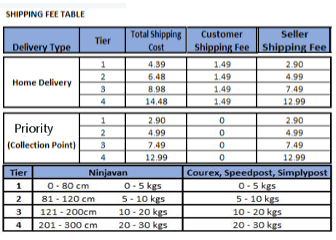

Yes, they do pickup the orders from your warehouse address provided in your Seller Center profile. Please be advised to set the package weight of your items on the Seller Center to 0.21 kg and above to route this to standard shipping providers moving forward.

You may go to Products > Manage Products > Choose SKU > Edit Details > Package Weight, you may refer on the image below:

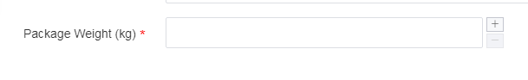

It should be automatic within 24 hours. In case that they didn't arrive within 24 hours, you may contact us so we can followup with them.

It's both measured by weight and dimension, whichever is higher. For items that is more than 30 kg in weight, it should be under Seller Own Fleet.

To clarify on that, weight and dimension is different computation. For example, charges for Tier 1 parcel is if item is within 5 kg or 80 cm in dimension, dimension is computed by Length + Width + Height.

For the installment plan, it will be like a regular order, it will be under installment by Lazada but your store will be paid full instantly once order is tagged as delivered. Please be advised that Ninja Van can only cater up to 29 kg of package. More than that and it should be under Seller Own Fleet.

For LazMall sellers, it has specific criterias. You may check the criterias thru your profile.

For non LazMall, you are not being charged for commission fees. Only LazMall sellers is being charged for commission fees. That depends on the categories of their items, approximately it is around 5%.

For non LazMall sellers, you were only charged of payment fee which is a fix rate of 2% of your retail price.

To apply for FBL, you will send to your item to our warehouse. You may create an Inbound Request by going to Products > Fulfillment by Lazada. The FBL warehouse where you will send the items will showup once request is done.

That is correct. There are certain items that is not applicable for return.

FBL warehouse

That is possible. You may set on the request that you will send it to us thru our logistics, the charges may depends on the total volume of the handled items and it will show up before finalizing the request.

GST is not yet included on the 2%, so it will be 2% + 7% GST.